Upgrading Power Networks

Introduction

In Australia, over the last few years, there has been a lot of talk about upgrading the power network. The electricity network upgrade involves connecting multiple transmission lines in parallel to reduce the power dissipation burden on each transmission line.

You might be asking yourself the following question: “Why would a power system have so much trouble coping with power demand?” There are two reasons. The first reason is the conversion from coal power generation to renewable energy. We all know that renewable energy is dependent on weather. When the weather is not suitable for renewable energy (no sunlight for solar cells and not wind for wind generators) little energy is generated and the remaining energy needs to be subsidised with coal power. However, when the weather is sunny and windy so much energy is generated that the power system cannot cope and might fail. We all know that the electricity network like any electrical system has maximum power limits that must not be exceeded. The second reason is the increase in power demand. New homes are constantly connecting to the power grid and more people are using computers, mobile phones, and the internet. Thus the second reason is growth in population and the semiconductor industry.

This article will use the power network model to show the benefits of such an upgrade.

Power System Model

The power network consists of generators (that produce AC (alternating current) voltage supply), transformers, circuit breakers, and loads. However, for simplicity, we will assume that the power system consists of DC (direct current) sources connected to resistors.

I have drawn the power network model circuit in PSpice student edition version 9.1:

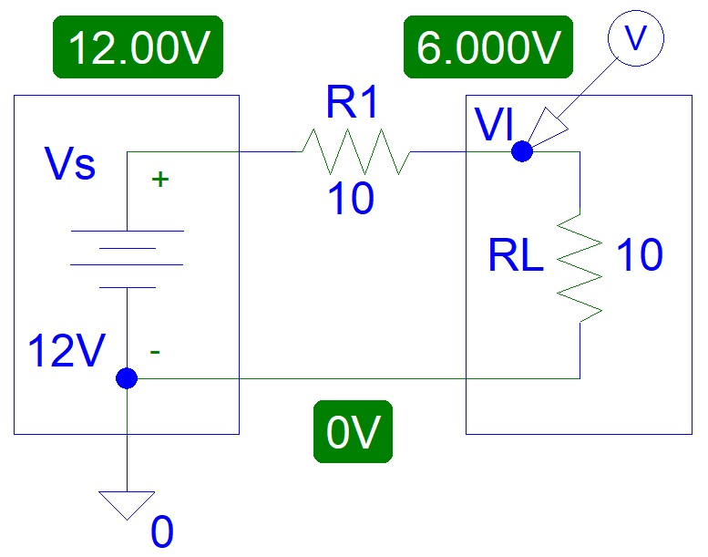
Figure 1: Power Network Model.

You can see the simulated voltage values, highlighted in green.

Watch what happens when we add a resistor in parallel that is equivalent to upgrading the power network:

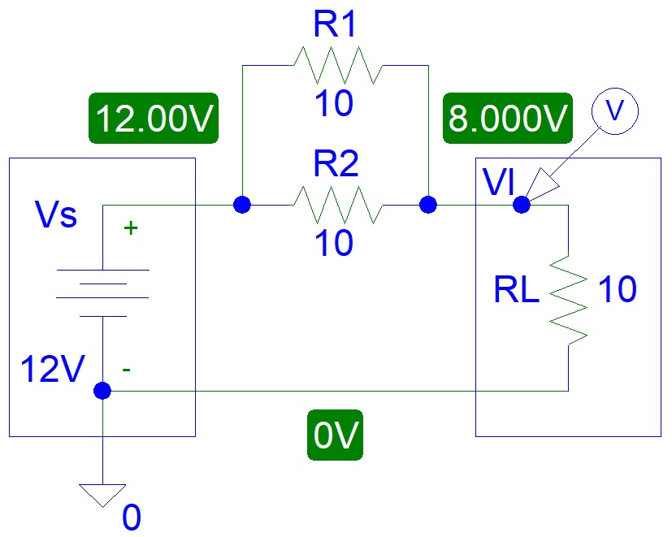
Figure 2: Upgraded Power Network Model.

The load voltage increased from 6 V to 8 V.

Now we add another resistor:

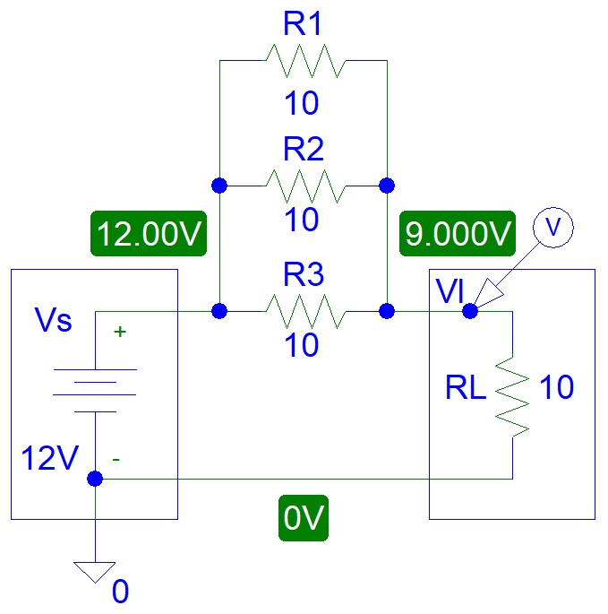
Figure 3: Upgraded Power Network Model.

Now the voltage is 9 V, higher than 8 V.

To find out what happens if we add 4 or more resistors and to calculate the power dissipation we can use Matlab software to generate simulated data and plots. To code the Matlab file we need to know a few simple equations.

If we connect multiple resistors in parallel the total resistance will equal:
$R_{T}=\frac{1}{\frac{1}{R_{1}}+\frac{1}{R_{2}}+\frac{1}{R_{3}}+\frac{1}{R_{4}}+...+\frac{1}{R_{N}}}$
(Where: N = Number of Resistors, $R_{T}=$Total Resistance (𝜴, ohms),
$R_{1}$, $R_{2}$and $R_{3}$ are first second, and third
resistors (𝜴, ohms) etc.)

The load voltage can be calculated from the voltage divider rule:

$V_{L}=\frac{V_{S}×R_{L}}{R_{T}+R_{L}}$
(Where: $V_{L}=$ Load Voltage (V, volts), $V_{S}=$ Supply Voltage (V, volts),
$R_{L}=$ Load Resistance (𝜴, ohms), $R_{T}=$ Total Resistance (𝜴, ohms))

Power equals:

$P=V×I=\left(I×R\right)×I=I^{2}×R={\left(\frac{V}{R}\right)}^{2}×R=\frac{V^{2}}{R}$
Where: P = Power (W, Watts), V = Voltage (V, Volts),
I = Current (A, Amps), R = Resistance (𝜴, ohms)

Matlab Simulations

I used Octave software instead of Matlab because Octave software is free.

The graph below shows how the total network resistance decreases.

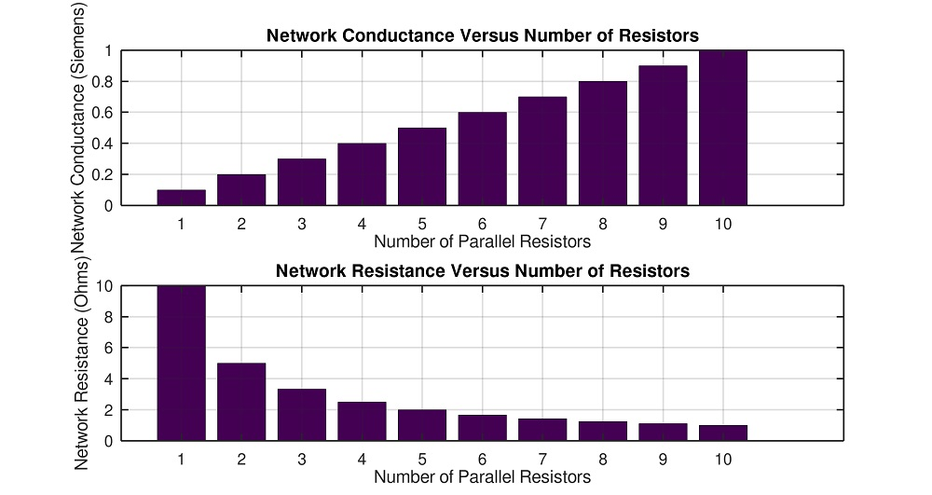
Figure 4: Network Resistance and Conductance.

Load voltage increases to 12 V but never reaches 12 V.

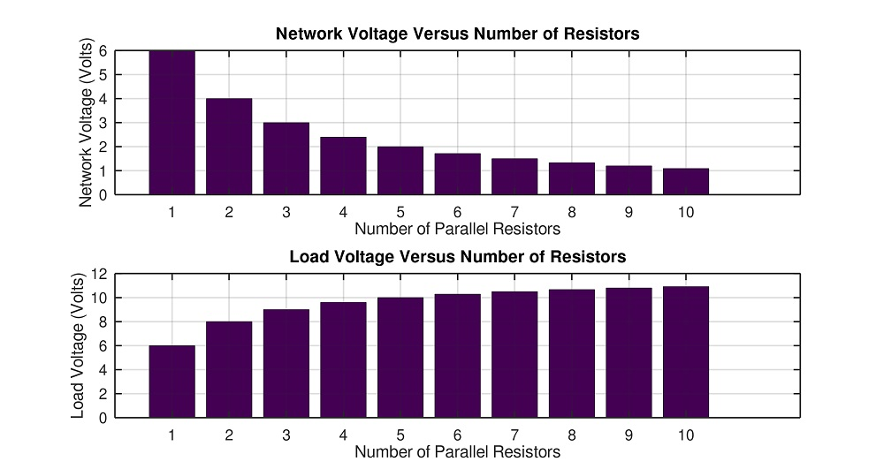
Figure 5: Voltages for Network and Load.

The graph below shows a drop in network power dissipation and an increase in load power:

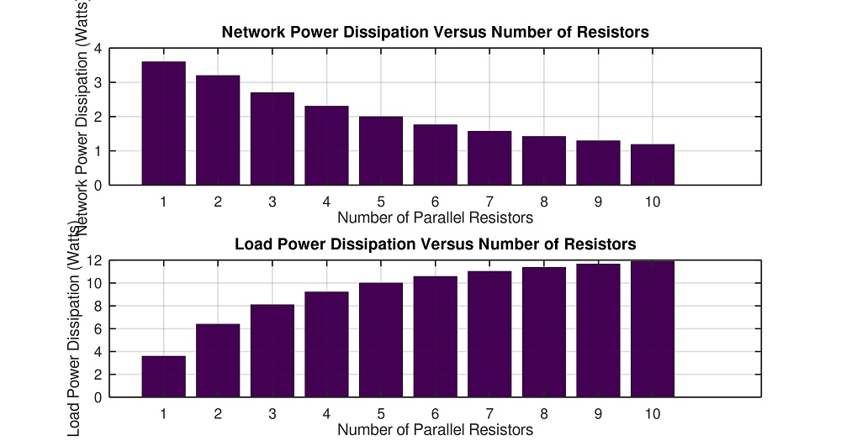
Figure 6: Power Dissipation for Network and Load.

The bar graph in Figure 7 is the most important plot. It shows a decrease in power dissipation for each resistor:

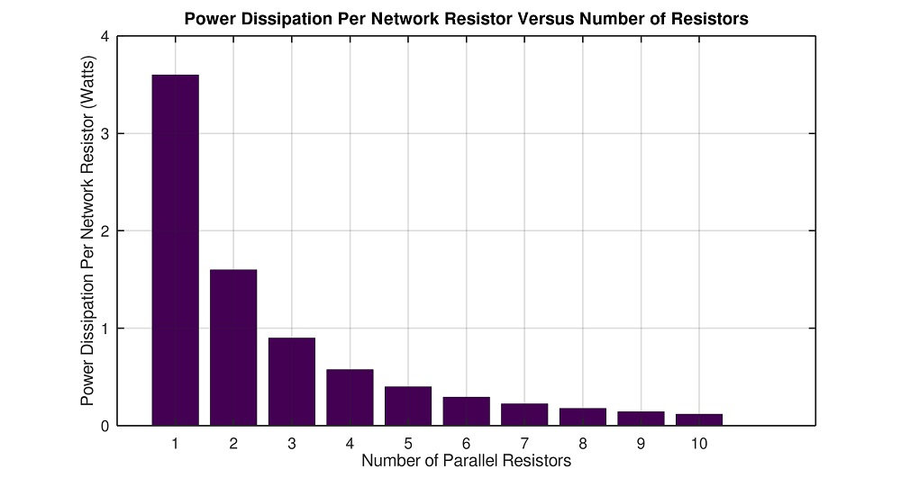
Figure 7: Power Dissipation for Each Resistor.

Discussion

From our power system model circuit, we can see that if you reduce the resistor values you will increase the current and thus power dissipation. Also, if you connect another resistor in parallel with RL, you will increase the power dissipation on the R1 resistor. This is equivalent to someone connecting another computer to a home socket or a new home connected to the power grid.

In a real power system, there is a control system that ensures that the average home load does not receive a lot more or a lot less than 240 V supply.

Conclusion

This article has proved via logical reasoning and numerical analysis that upgrading the electricity network is essential. We hope that no one will stand in the way of such an important project.

Appendix (Matlab Code)
clear all;close all

Vs=12;
R1=10;
RL=10;
LnWd=2;
FtSz=20;

G1Cumulative=0;
for a=1:10
G1Cumulative=G1Cumulative+1/R1;
NumbResist(a)=a;
G1a(a)=G1Cumulative;
R1a(a)=1/G1a(a);
V1a(a)=Vs*R1a(a)/(R1a(a)+RL);
VLa(a)=Vs*RL/(R1a(a)+RL);
P1a(a)=V1a(a)*V1a(a)/R1a(a);
P1aEach(a)=P1a(a)/a;
PLa(a)=VLa(a)*VLa(a)/RL;
end

figure;
subplot(2,1,1);bar(NumbResist,G1a)
title('Network Conductance Versus Number of Resistors','FontSize',FtSz)
ylabel('Network Conductance (Siemens)','FontSize',FtSz)
xlabel('Number of Parallel Resistors','FontSize',FtSz)
H=gca;set(H,'FontSize',FtSz,'LineWidth',LnWd);
grid on

subplot(2,1,2);bar(NumbResist,R1a)
title('Network Resistance Versus Number of Resistors','FontSize',FtSz)
ylabel('Network Resistance (Ohms)','FontSize',FtSz)
xlabel('Number of Parallel Resistors','FontSize',FtSz)
H=gca;set(H,'FontSize',FtSz,'LineWidth',LnWd);
grid on

figure;
subplot(2,1,1);bar(NumbResist,V1a)
title('Network Voltage Versus Number of Resistors','FontSize',FtSz)
ylabel('Network Voltage (Volts)','FontSize',FtSz)
xlabel('Number of Parallel Resistors','FontSize',FtSz)
H=gca;set(H,'FontSize',FtSz,'LineWidth',LnWd);
grid on

subplot(2,1,2);bar(NumbResist,VLa)
title('Load Voltage Versus Number of Resistors','FontSize',FtSz)
ylabel('Load Voltage (Volts)')
xlabel('Number of Parallel Resistors','FontSize',FtSz)
H=gca;set(H,'FontSize',FtSz,'LineWidth',LnWd);
grid on

figure;
subplot(2,1,1);bar(NumbResist,P1a)
title('Network Power Dissipation Versus Number of Resistors','FontSize',FtSz)
ylabel('Network Power Dissipation (Watts)','FontSize',FtSz)
xlabel('Number of Parallel Resistors','FontSize',FtSz)
H=gca;set(H,'FontSize',FtSz,'LineWidth',LnWd);
grid on

subplot(2,1,2);bar(NumbResist,PLa)
title('Load Power Dissipation Versus Number of Resistors','FontSize',FtSz)
ylabel('Load Power Dissipation (Watts)','FontSize',FtSz)
xlabel('Number of Parallel Resistors','FontSize',FtSz)
H=gca;set(H,'FontSize',FtSz,'LineWidth',LnWd);
grid on

figure;
bar(NumbResist,P1aEach)
title('Power Dissipation Per Network Resistor Versus Number of Resistors','FontSize',FtSz)
ylabel('Power Dissipation Per Network Resistor (Watts)','FontSize',FtSz)
xlabel('Number of Parallel Resistors','FontSize',FtSz)
H=gca;set(H,'FontSize',FtSz,'LineWidth',LnWd);
grid on

